Add custom paging using Global variables
Step 1:
Build the report
Step 2:
Add a page footer and drop 4 textboxes
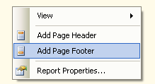
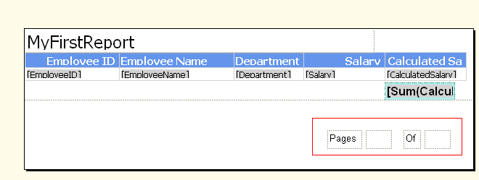

Step 3:
Choose the 2nd textbox and click on the Expression
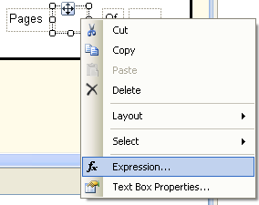

Step 4: [=Globals!PageNumber ]
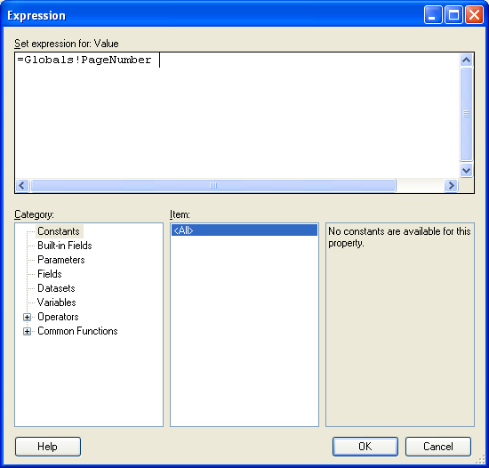
Step 5: Choose the 4th textbox and click on the Expression [=Globals! TotalPages ]
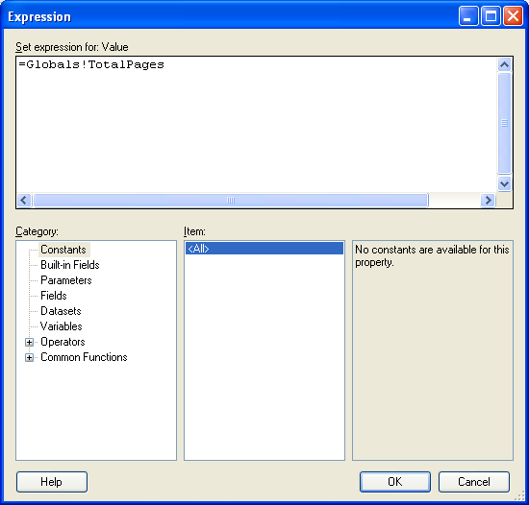
Step 6:
